**PROJECT REPORT**

**TITLE NAME:Plugging into the future:An Exploration of Electricity consumption patterns.**

**1.INTRODUCTION:**

**1.1. OVERVIEW:**

**Electric Energy consumption is energy consumption in the form of electrical energy. About a fifth of Global energy is consumed as electricity; for residential, industrial, commercial, transportation and other purposes.**

**India is the world largest producer of electricity in the world. During the fiscal year (FY) 2021-2022, the total Electricity Generation in the country was 1719 Twh, of which 1984 Twh was generated by utilities. The gross electricity consumption per capita in FY2019 was 1208 kwh. The electricity energy consumption (EEM) in kilowatt-hours(kwh) is determined as the Electrical energy Required to degrade 1 kg of a contaminant(c) in the polluted medium.**

**1.2. PURPOSE:**

**Electricity is a very powerful innovation in science. Electricity is widely used in all sectors like entertainment, engineering, healthcare, transport and communication, household, outdoors, office, commercial, space, and fuel.**

* **People use electricity for lighting, heating, cooling, and refrigeration, and for operating appliances, computers, electronics, machinery and public transportation systems.**
* **We also find the high-speed optical fibers rely on an electrical signal at each end of the line. Without Electricity communication would reduce to letters, flag-waving, lighting fires, and shouting at each other.**
* **We use electricity for accessing data from modes like fiber and LAN in our workspace.**
* **Electricity consumption supplying water at our home, etc.**
* **Wireless lights such as solar powered lamps convert light to electricity.**

**2.PROBLEM DEFINITION:**

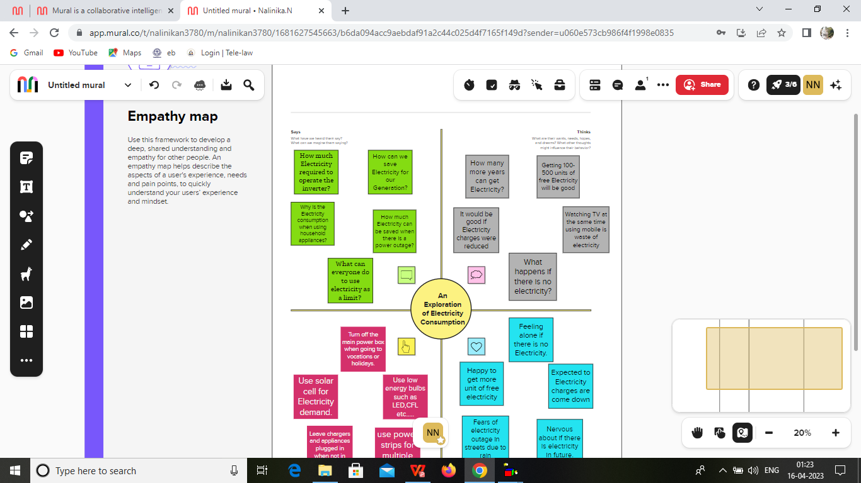

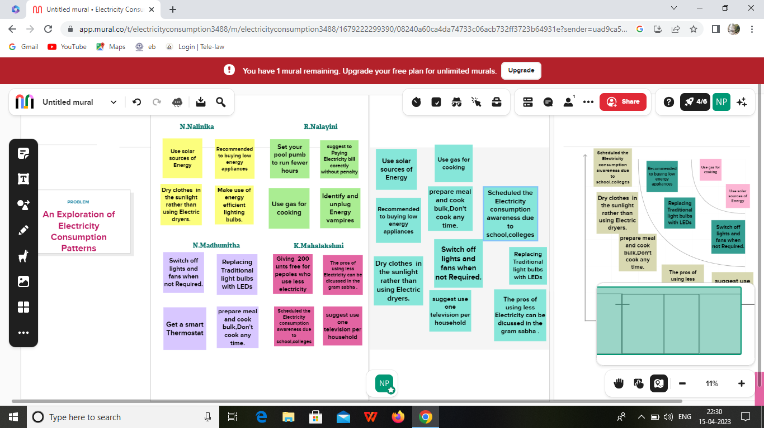

**3. RESULTS:**

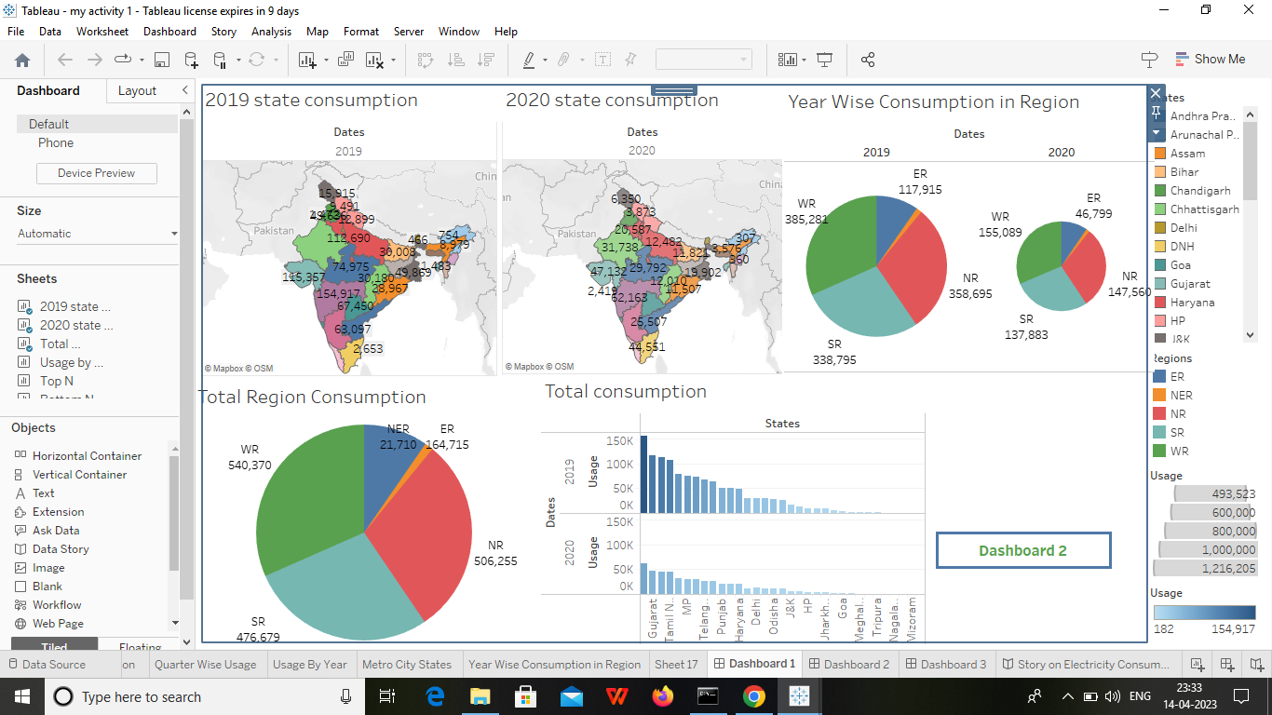

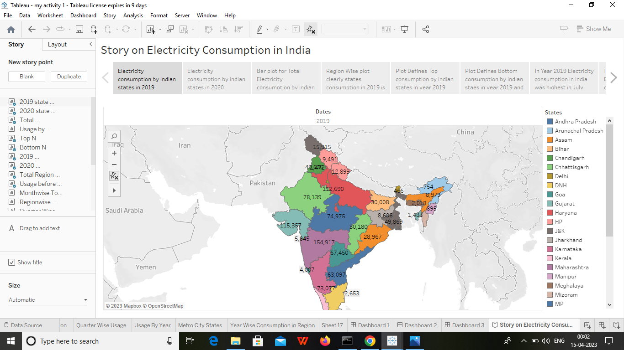

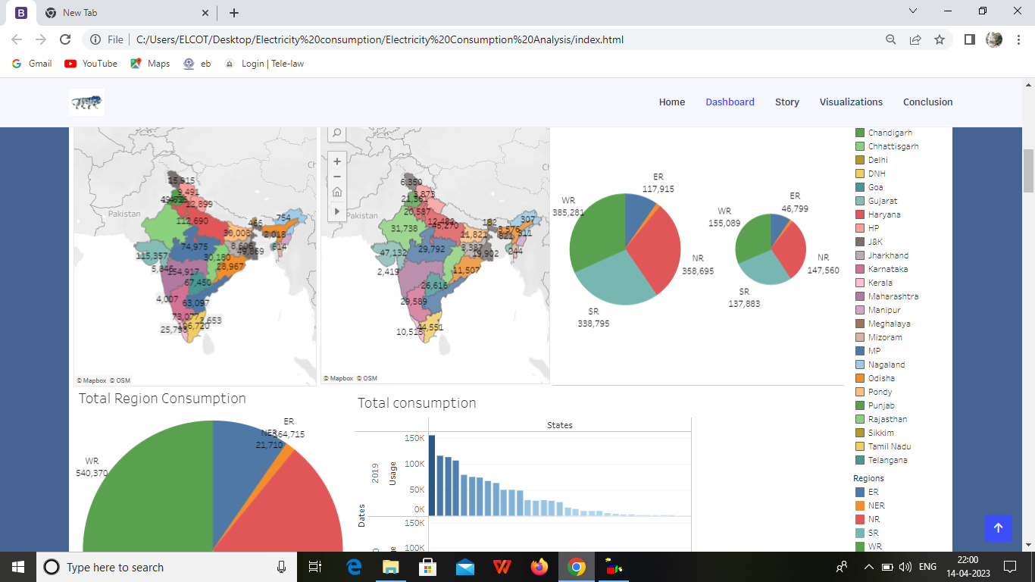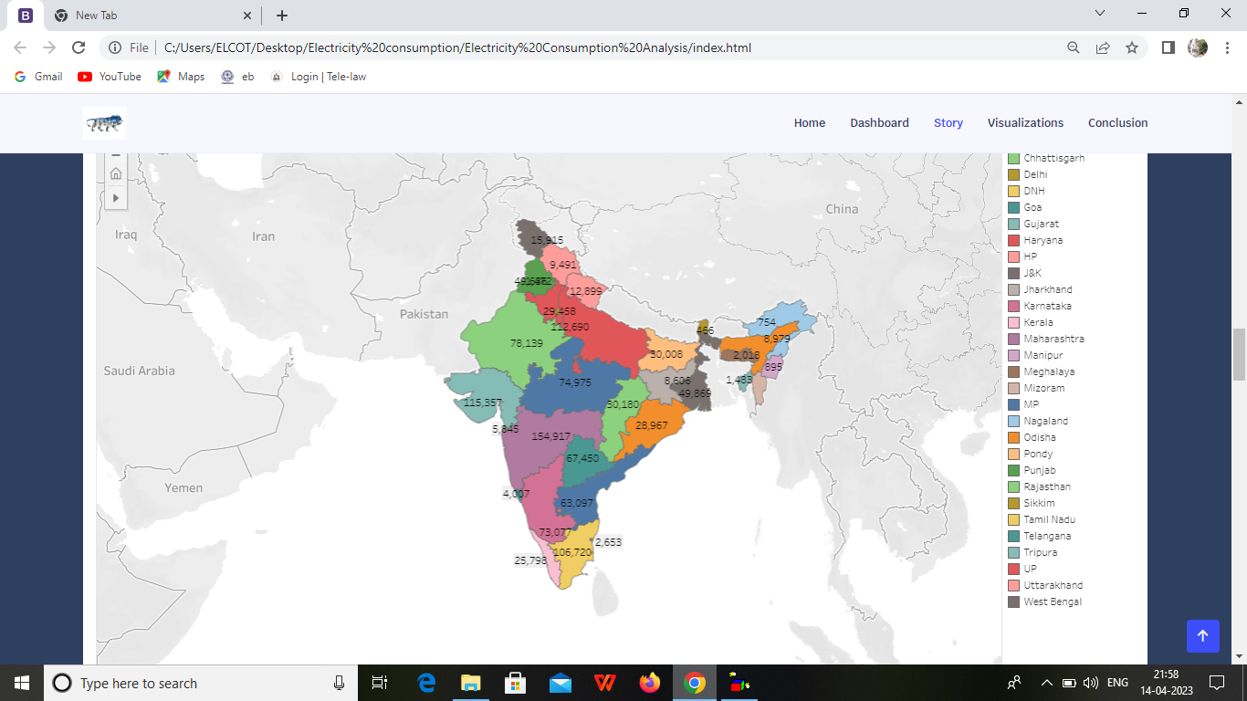

**4.ADVANDAGES AND DISADVANDAGES:**

**4.1. ADVANDAGES:**

* **It's clean, safe, cheap, and convenient maintenance of energy.**
* **It causes barely any pollution compared to other ways of creating or generating electricity.**
* **A station can operate and run for long periods of time.**
* **Hydroelectricity produces no gas emissions or waste.**
* **It's renewable.**
* **Lower maintenance cost.**
* **We all know that it can be set up in many sizes.**
* **No tailpipe emission.**
* **It doesn’t require as many employees.**
* **Reduce greenhouse emission.**

**4.2. DISADVANDAGES:**

* **More expensive than gasoline.**
* **Sometimes messes up wildlife.**
* **Depended on precipitation.**
* **Cost of construction.**
* **Change in river or stream quality.**
* **An electric vehicle is not completely emission free.**
* **In electricity there are a limited number of feasible sites for many dams.**
* **Hydroelectric can affect power production natural seasonal changes in river and ecosystems can be destroyed.**
* **Drought can affect power production.**

**5. APPLICATION:**

* **Entertainment activities like Watching TV, listening to music from an MP3 player, and playing movies on DVDs, VCRs, and VCDs, all require the use of electricity.**
* **Electricity is used to light the roads, heat water in a pool, the lawnmower is used to cut grass and uses electricity and water sprinklers also use electricity.**
* **The use of electricity is essential in the healthcare sector like the use of electricity in an operation theatre and for running medical devices and machines.**
* **Electricity is even required for the construction of buildings and structures like building houses, welding of materials, and installing windows and gates.**
* **Traveling long distances is also possible because of electricity.**

**6. CONCLUSION:**

**Electricity is the backbone of modern society. Our life will go back to the primitive age without electricity. There is a need for rational use of electricity, as it is largely produced from non-renewable sources like coal and water. The aim of this project was to identity the variables that influence the generations, the consumption and the price of the electricity in United states.**

**7.FUTURE SCOPE:**

* **Most of the water is just wastewater by opening the tap and wasting the water for no purpose.**
* **We must consider both the scarcity of water and the necessity of electricity in our life.**
* **Without having electricity in the households would mean returning to the dark ages.**
* **We can save electricity by switching off the appliances when they are not in use.**
* **We must understand the fact that electricity is limited resources.**

**PRESENTed BY**

1. **Nalinika(Leader)**

**R.Nalayini**

**N.Madhumitha**

**K.Mahalakshmi**